Option 1: Force to balance the portfolio exposure: increase value exposure and reduce momentum exposure

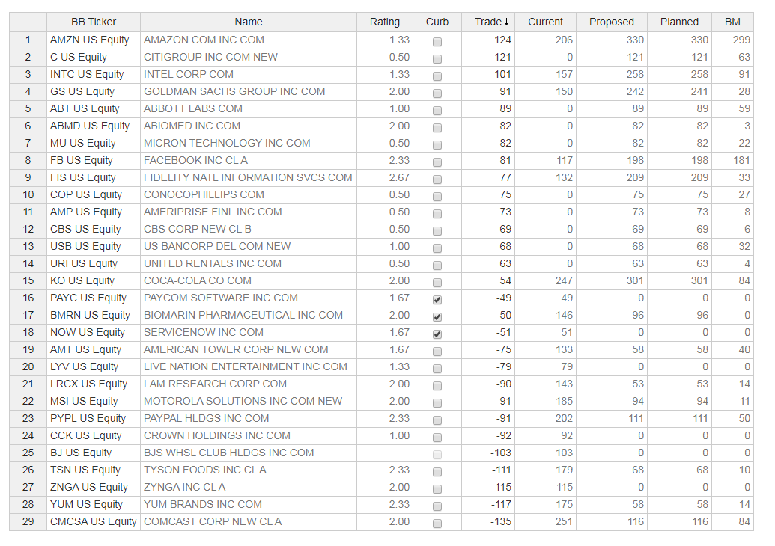

Option 2: keep current exposure, just run optimizer using updated ratings

